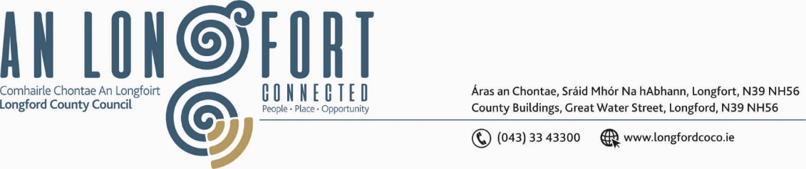

**GRANARD MUNICIPAL DISTRICT**

***Please note meeting will be held on Microsoft Teams.***

**17th November 2021.**

**To: Each Member of Granard Municipal District.**

**Dear Member,**

You are requested to attend a Meeting of Granard Municipal District to be held on **Microsoft Teams** on **Tuesday 23rd November 2021 at 3.30pm** to transact business, as set out on the Agenda hereunder.

**Yours sincerely**,

Ann Marie Mc Keon

______________________

**Ann Marie Mc Keon,**

**Meetings Administrator.**

**AGENDA**

Prayer before meeting.

**1.** Confirmation of Minutes as follows: -

* Granard Municipal District Committee Meeting held on 28th September 2021 – copy enclosed.
* Granard Municipal District Meeting held on the 28th September 2021 – copy enclosed.
* Granard Municipal District Committee Meeting held on 14th October 2021 – copy enclosed.
* Granard Municipal District Meeting held on 14th October 2021 – copy enclosed.
* Granard Municipal District Meeting held on the 26th October 2021 – copy enclosed.
* Granard Municipal District Committee Meeting held on the 26th October 2021 – copy enclosed

**2.** Matters arising from Minutes.

**3.** Declaration of Interest by Members.

**4.** Management Report incorporating Area Engineer’s Progress Report

- to follow.

**5.** Granard Public Art Features.

**6.** Proposed Projects/Expression of interest – enclosed.

**7.** Notices of Motions, submitted by Councillors, as listed hereunder –

**Councillor Garry Murtagh**

I am calling on Longford County Council to include the stretch of roads, Aughnacliffe to Esker Cross, the L-1039-0 and the L1036-0 for salting/gritting into the Winter Salting Roads Programme 2021/2022.

**Councillor PJ Reilly**

I wish to put a notice of motion to the meeting for an electric power point to be installed in the town of Granard for charging electric cars in the Granard Area.

**Councillor Colin Dalton**

“I call on Longford County Council to carry out a small media campaign to advertise the out of hours emergency number”.

**Councillor Turlough Mc Govern**

i “I call on Longford County Council to engage with Tuath in order to move on the major multi million-euro refurbishment earmarked in May 2018 for Colmcille Terrace”.

ii “I call on Longford County Council to carry out road works and improvements around the Greville Apartments. This road is being used as a public road and the volume of traffic on it is a major factor in the road condition dis-improving”.

**8.** Correspondence

1. Correspondence dated 28th September 2021 - Received from Irish Water – enclosed.
2. Correspondence dated 5th October 2021 - Minister for Rural and Community DevelopmentRe Local Improvement Schemes – enclosed.